5-Fold Cross-Validation & Baseline Comparison — Notes

Github: https://github.com/FahadAftab14/Phishing-Detection

1. Scope Decision
True 5-fold CV retraining every deep model (fusion, BERT, RoBERTa, DistilBERT) on the full 253K-row dataset was estimated at 15-18 hours of GPU time, not feasible in a single session. Decided to run all CV experiments on a stratified 35,000-row subsample (preserving the real ~98.8/1.2 class ratio) instead. Traditional ML baselines were cheap enough to not need this tradeoff, but were run on the same subsample and fold split for fair comparison.
- Built one shared stratified 5-fold split (email_id + fold number) up front, reused by every model, so all significance testing later would be properly paired.
- Important limitation: results from this subsample are not directly comparable to the earlier full-dataset results (e.g. Task 2's DistilBERT baseline scored F1 0.899 on the full data vs 0.697 here). Smaller subsample means far fewer phishing examples per fold (~330 vs ~2,500), which hurts rare-class performance.

2. Issues Encountered
- Fusion model produced NaN loss/weights partway through 5-fold training. Traced to fp16 (mixed precision) combined with the LSTM branch -- a known instability source when recurrent layers are trained in fp16. Fixed by disabling fp16 specifically for the fusion runs, adding gradient clipping (max_grad_norm=1.0), and lowering the learning rate (3e-5). Also added a post-training NaN check so any future occurrence fails that fold gracefully instead of crashing or silently corrupting results.
- Fusion model was deliberately NOT warm-started from the previously saved full-dataset weights for this evaluation, since those weights were trained on data overlapping this subsample's test folds -- would have leaked label information into the CV result. Every fold trained fully from scratch.

3. Results: Full Comparison
All models evaluated on the identical 35K-row stratified subsample and 5-fold split. Sorted by F1.
Model | Accuracy | Precision | Recall | F1 | ROC-AUC
Fusion | 0.9946 | 0.855 | 0.653 | 0.740 | 0.949
LinearSVC | 0.9944 | 0.890 | 0.600 | 0.716 | 0.963
DistilBERT | 0.9941 | 0.860 | 0.592 | 0.697 | 0.939
BERT | 0.9939 | 0.888 | 0.558 | 0.652 | 0.928
Logistic Regression | 0.9894 | 0.536 | 0.769 | 0.631 | 0.968
RoBERTa | 0.9925 | 0.751 | 0.391 | 0.491 | 0.810
Random Forest | 0.9917 | 0.954 | 0.308 | 0.466 | 0.949
Multinomial NB | 0.9878 | 0.456 | 0.165 | 0.242 | 0.923

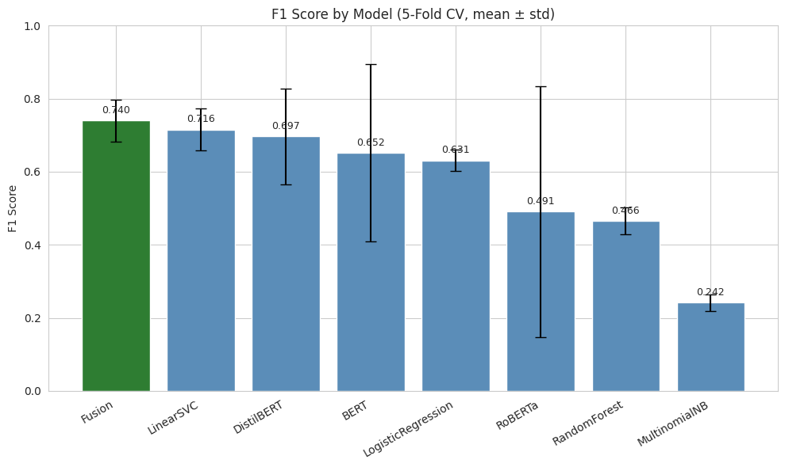
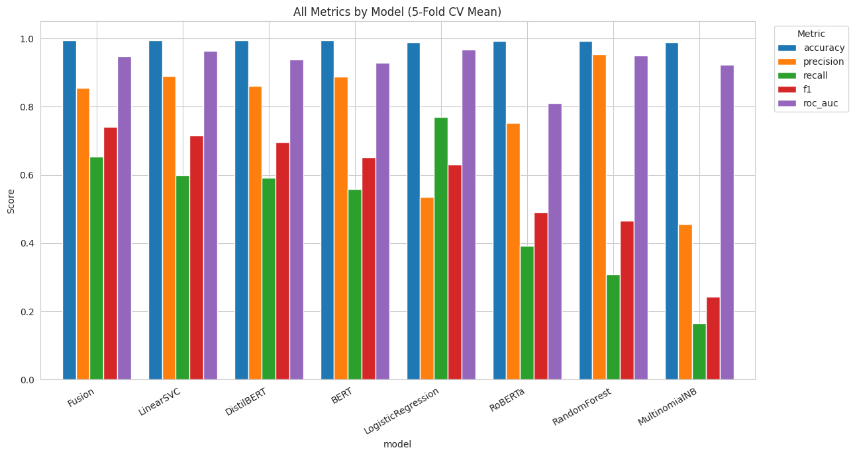

4. Findings
- Fusion achieved the best F1 (0.740) and best accuracy (0.9946) of every model tested, ahead of every single-modality transformer and every traditional ML baseline.
- Fusion did not have the best ROC-AUC -- Logistic Regression (0.968) and LinearSVC (0.963) both ranked higher.
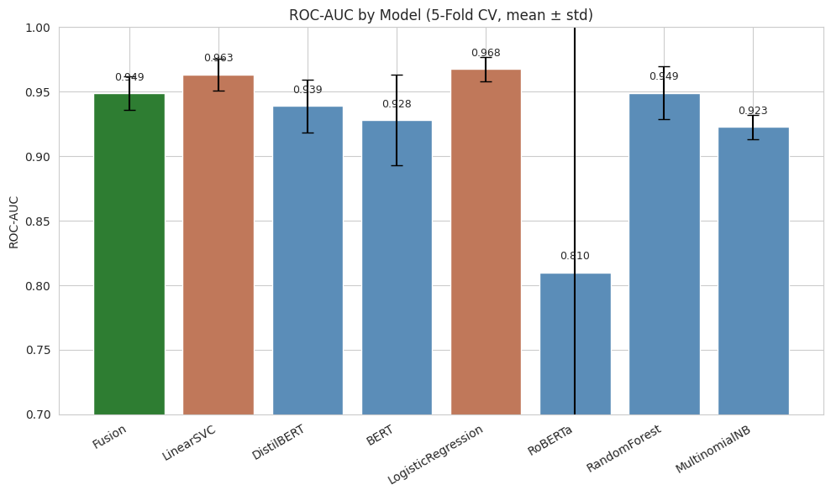
- RoBERTa was notably unstable under the same training conditions as BERT/DistilBERT (F1 std of 0.30, recall std of 0.30) -- some folds likely collapsed toward always predicting benign. Same code and hyperparameters were used across all three transformers, so this reflects RoBERTa's known sensitivity to learning rate/fine-tuning setup rather than a bug in the evaluation harness. Documented as-is rather than retuned only for RoBERTa.
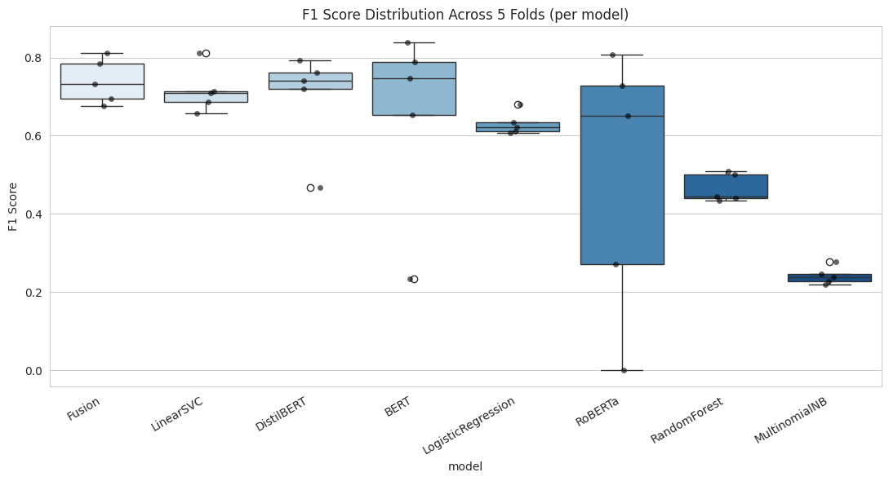

5. Statistical Significance Testing
Paired Wilcoxon signed-rank test, Fusion vs each other model, per metric, using the matched 5-fold scores.
- None of the F1 comparisons reached significance at p < 0.05, despite some large mean differences (e.g. Fusion vs Random Forest: +0.274 F1, p = 0.0625).
- Important limitation: with only 5 paired folds, 0.0625 is the smallest p-value the Wilcoxon signed-rank test can mathematically produce when all folds favor the same model. This is a hard floor from the sample size, not evidence that the difference is unreal. A real, consistent improvement can still fail to reach conventional significance at n=5
- Fusion vs LinearSVC (the closest competitor) showed the smallest, least consistent gap (diff 0.024, p = 0.4375) -- the one comparison where the result is genuinely closer to a toss-up rather than just underpowered.
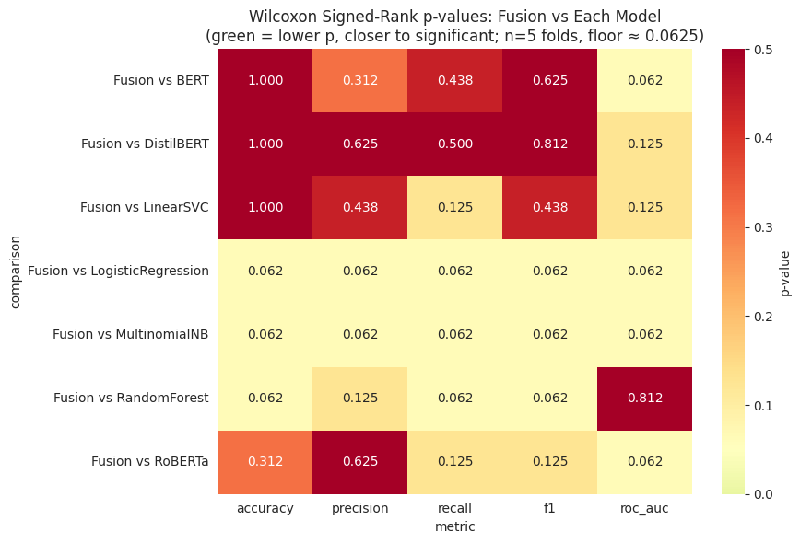

6. Weaknesses, Gaps, and Plan of Action
- Significance testing is underpowered at n=5 folds. Future work: increase fold count (e.g. 10-fold) or use a paired bootstrap test instead of Wilcoxon, either of which would have more power to detect the same-sized differences seen here.
- RoBERTa's instability was not investigated further (e.g. lower learning rate specifically for RoBERTa) since the goal here was a fair, identical-conditions comparison across baselines, not maximizing every baseline's individual score.
- The ROC-AUC vs F1 disagreement (linear models rank higher on ROC-AUC, fusion ranks higher on F1)

